
Name______________________________________________________ Class______________

Quiz on “The Music Man”

Matching: Match the words in the first column to their description in the second column. Put the correct letter on the line.

- _____ Marian

- _____ Professor Hill

- _____ 76 Trombones

- _____ Winthrop

- _____ Meredith Willson

- _____ River City, Iowa

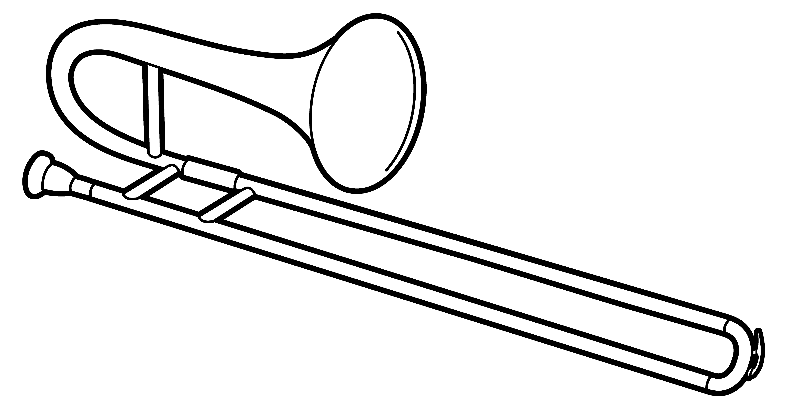
- _____ Gary, Indiana

- _____ Pick a Little, Talk a Little
  - The Music Man

  - Marian’ brother

  - The town where “The Music Man” takes place

  - Big dance number in which Hill imitates the sounds of all the instruments

  - The song in which the ladies “gossip” about Marian

  - The conservatory where Hill claimed to get his degree

  - The librarian and music teacher

  - The composer of “The Music Man”

